To begin, make sure that you right click on the schema name and select “Set as Default Schema.” This is to ensure that when you edit the database, the settings recognize that you are in that specific database.

# Macintosh HD:Users:legalllab:Desktop:Screen Shot 2019-08-14 at 11.58.50 AM.png

This is an overview of what the tables and stored procedures looks like on the schema drop-down menu.

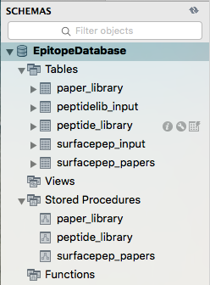

# Macintosh HD:Users:legalllab:Desktop:Screen Shot 2019-08-20 at 1.43.33 PM.png

# ‘surfacepep_papers’ Table

This table stores the information from the local surfacepep_input.csv file.

This table stores the information for the identification number of the paper (*ref*), the author of the reference (*first_author*), the journal of the paper (*journal*), the year of the paper (*year*), the cells used in the experiment (cells), the assay (*assay*), the sequencing method (*sequencing*), the number of peptides (*num_peps*), the data (*data*), the HLAs identified in the paper (*HLAs*), the HLA assignment (*HLA_assignment*), \any additional comments (*comments*), the data origin (*data_origin*), the search engine (*search_engine*), the search parameters such as precursors or fragments masses (*search_param*), the false discovery rate (*false_dscvr_rate*), and any post-translational modifications (*posttrans_mod*).

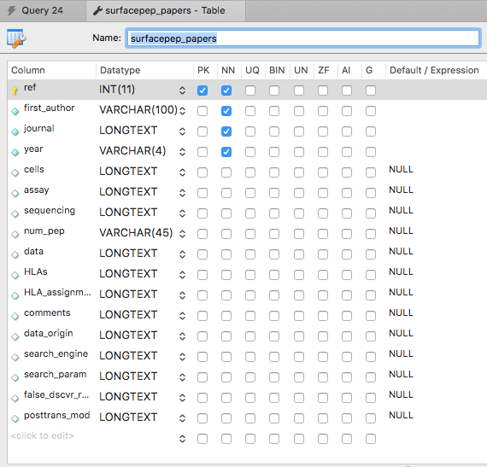

This is an example of what the .csv file can look like to be loaded onto the database.

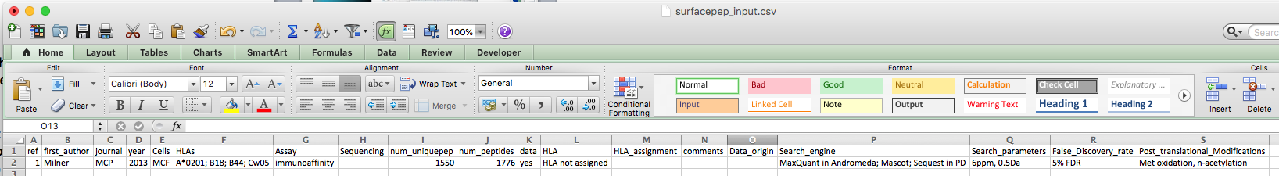

To load the .csv file, click on the “Import” button and select the surfacepep_input.csv file. 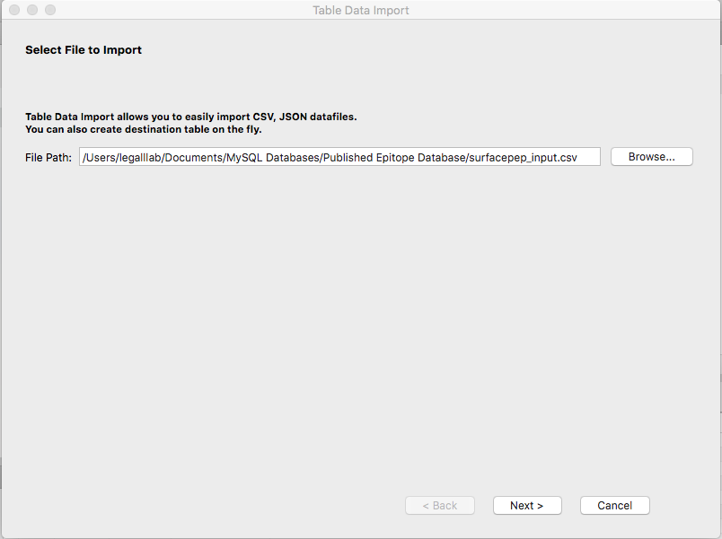

Select “Use existing table:”, “Truncate table before import”, and select “EpitopeDatabase.surfacepep_papers”.

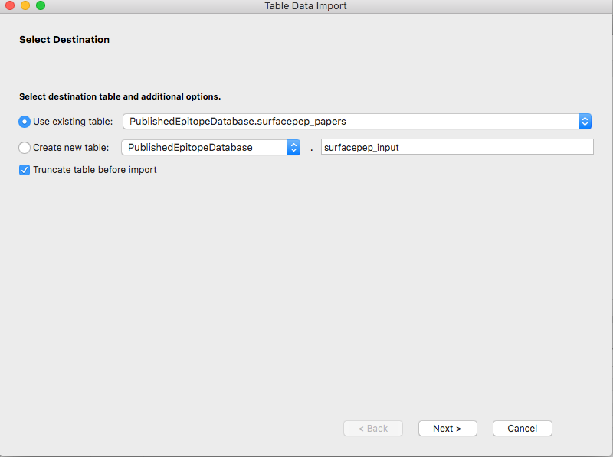

Configure the import settings by clicking on the tool symbol. Change the “Field Separator” to the “,”.

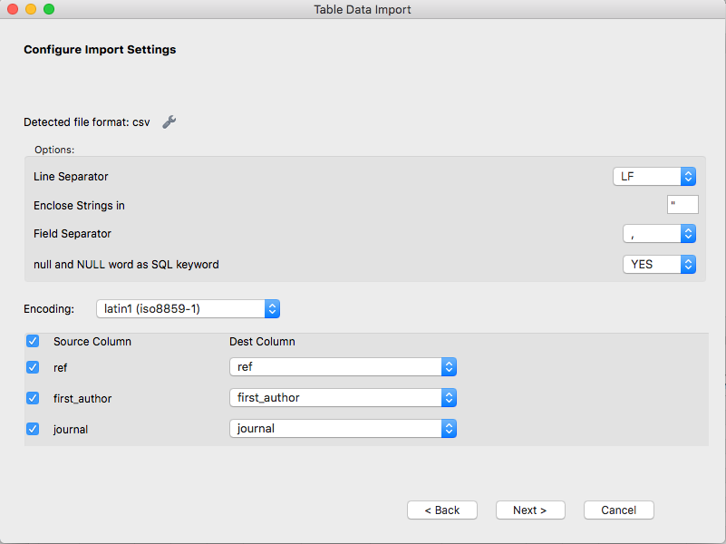

To view the loaded table, click the lightning bolt icon next to the stored procedure titled ‘surfacepep_papers’ that has the following SQL script.

-- increment the ref by 1 each time a new entry is added

ALTER TABLE EpitopeDatabase.surfacepep_papers AUTO_INCREMENT = 1;

-- insert information from surfacepep_input table into the surfacepep_papers table if not already in surfacepep_papers table

INSERT

INTO

EpitopeDatabase.surfacepep_papers (ref, first_author, journal, year, cells, assay, sequencing, num_pep, data, HLAs, HLA_assignment, comments, data_origin, search_engine, search_param, false_dscvr_rate, posttrans_mod)

SELECT

ref, first_author, journal, year, Cells, Assay, Sequencing, num_pep, data, HLAs, HLA_assignment, comments, Data_origin, Search_engine, Search_parameters, False_Discovery_rate, Post_translational_Modifications

FROM

EpitopeDatabase.surfacepep_input

WHERE

(EpitopeDatabase.surfacepep_input.ref NOT IN (SELECT ref FROM EpitopeDatabase.surfacepep_papers));

-- select all from the surfacepep_papers table

SELECT * FROM EpitopeDatabase.surfacepep_papers;

The table should look something like the following. Macintosh HD:Users:legalllab:Desktop:Screen Shot 2019-08-15 at 8.53.41 AM.png

# ‘paper_library’ Table

This table stores the information from the local surfacepep_input.csv file.

This table stores the information for the reference of the paper (*ref*), the first author of the paper (*author*), the amount of peptides mentioned in the paper (*num_pep*), and the number of unique peptides in that paper (*num_uniquepep*).

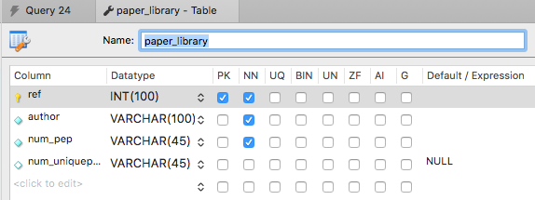

This is an example of what the .csv file can look like to be loaded onto the database.



To load the .csv file, click on the “Import” button and select the surfacepep_input.csv file.



Select “Use existing table:”, “Truncate table before import”, and select “EpitopeDatabase.surfacepep_papers”.

Macintosh HD:Users:legalllab:Desktop:Screen Shot 2019-06-24 at 2.33.39 PM.png

Configure the import settings by clicking on the tool symbol. Change the “Field Separator” to the “,” and the Encoding to latin1.



To view the loaded table, click the lightning bolt icon next to the stored procedure titled ‘paper_library’ that has the following SQL script.

-- insert information from surfacepep_input table into the paper_library table if not already in paper_library table

INSERT

INTO

EpitopeDatabase.paper_library (ref, author, num_pep, num_uniquepep)

SELECT

ref, first_author, num_pep, num_uniquepep

FROM

EpitopeDatabase.surfacepep_input

WHERE

(EpitopeDatabase.surfacepep_input.ref NOT IN (SELECT ref FROM EpitopeDatabase.paper_library));

-- select all from the paper_library table

SELECT * FROM EpitopeDatabase.paper_library;

The table should look something like the following.

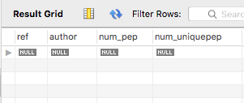

# ‘peptide_library’ Table

This table stores the information from the local peptidelib_input.csv file.

This table stores the information for the identification number of the paper (*id*), the peptide sequence (*seq*), the length of the peptide (length), the accession number of the peptide (*access_num*), the protein name of the peptide (*prot_name*), the gene name of the peptide (*gene_name*), the HLA identity (*HLA_identity*), the HLA class (*HLA_class*), the post-translational modifications of the peptide (*posttrans_mod*), any extra information for that peptide (*comments*), and the sample that the peptide came from (sample).

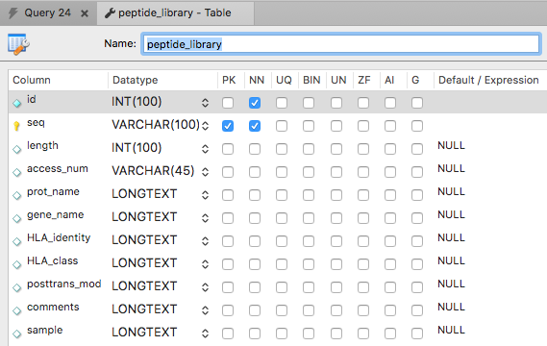

This is an example of what the .csv file can look like to be loaded onto the database.

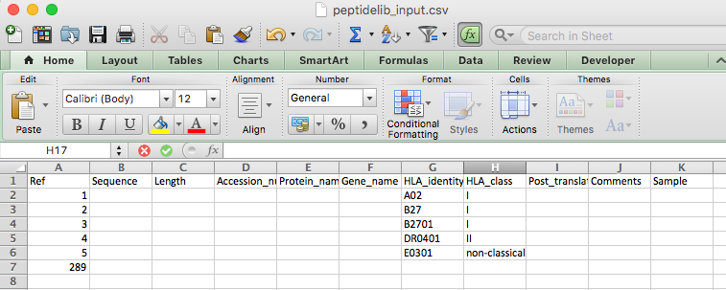

To load the .csv file, click on the “Import” button and select the peptidelib_input.csv file.

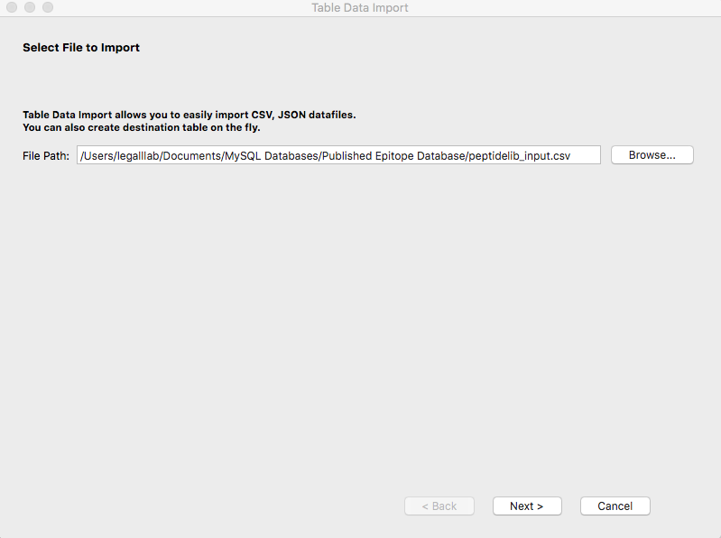

Select “Use existing table:”, “Truncate table before import”, and select “EpitopeDatabase.peptidelib_input”.

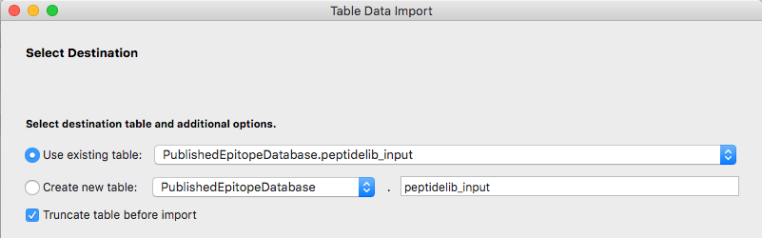

Configure the import settings by clicking on the tool symbol. Change the “Field Separator” to the “,” and the Encoding to latin1.

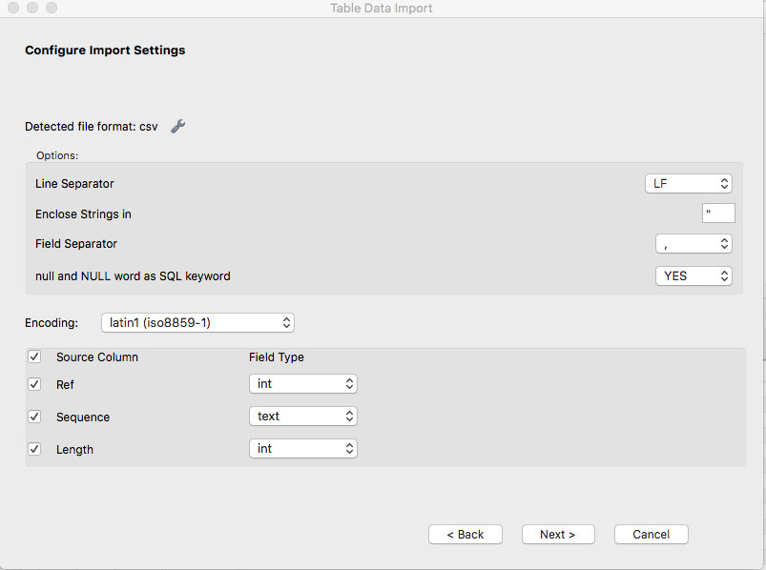

To view the loaded table, click the lightning bolt icon next to the stored procedure titled ‘peptide_library’ that has the following SQL script.

-- insert information from peptidelib_input table into the peptide_library table if not already in peptide_library table

INSERT

INTO

EpitopeDatabase.peptide_library (id, seq, length, access_num,prot_name, gene_name, HLA_identity, HLA_class, posttrans_mod, comments, sample)

SELECT

Ref, Sequence, Length, Accession_number, Protein_name, Gene_name, HLA_identity, HLA_class, Post_translational_modifications, Comments, Sample

FROM

EpitopeDatabase.peptidelib_input

WHERE

(EpitopeDatabase.peptidelib_input.Ref NOT IN (SELECT id FROM EpitopeDatabase.peptide_library));

-- select all from the peptide_collection table

SELECT * FROM EpitopeDatabase.peptide_library;

The table should look something like the following.

